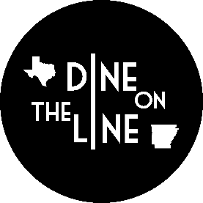 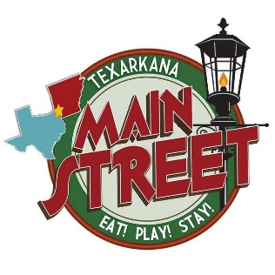 2018 Dine on the Line Sponsor

2018 Sponsorship Form
Sponsorship Level (Circle one)
Presenting Sponsor-$7500
State Line-$5000
Broad Street-$2500
Main Street-$1500
Hotel Grim-$1000
Union Station-$500
Spoon and Fork-$300
Dine on the Line $100 Club
Name of Organization or Individual
______________________________________________________________________
Contact Name and Phone Number
_______________________________________________________________________
Billing Address
_______________________________________________________________________
- I would prefer to pay by credit card. Please have someone contact for payment.
Contact Name and phone number for payment by credit card:
____________________________________________________________________
Please send completed form by email to Stacy Mayo @ SJames2879@aol.com.

