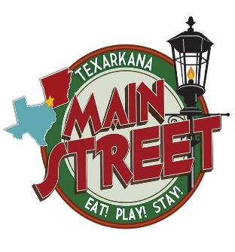& 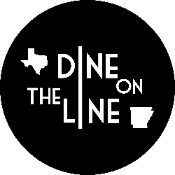
10.6.18

Levels of Sponsorship:
Presenting Sponsor
$7500
Logo on all advertisement as Presenting Sponsor and all Promotional Items (including front of T Shirts)
Dine on the Line Presented by “Your logo here”
Free Vendor Space (if needed)
Special acknowledgement during event program
2 Premium reserved tables (12 tickets) near stage

State Line Sponsor
$5000
Logo on Back of Shirt
Logo on Stage Banner
Logo on flyers for advertisement
Logo on table
Free Vendor Space (if needed)
2 premium reserved tables (12 tickets) near stage

Broad Street Sponsor
$2500
Logo on stage Banner
Logo on flyers for advertisement
Logo on table
Free Vendor Space (if needed)
1 premium table (6 tickets) near stage

Main Street Sponsor
$1500
Logo on flyers for advertisement
Logo on table
1 reserved table (6 tickets)

Hotel Grim Sponsor
$1000
Logo on Flyers
Logo on Table
1 reserved table (4 tickets)

Union Station Sponsor
$500
Logo on Flyers
Logo on Table
1 reserved table (2 seats)

Spoon and Fork Sponsor
$300
Logo on table
1 reserved table (2 seats)

Dine on the Line 100 Club
$100
Name on Poster Near Stage

All levels of sponsorship are Tax Deductible with Main Street Texarkana’s 501c3 Status as a Non-profit Organization
Contracts and special arrangements will be forth coming if you agree to partner with Dine on the Line and Main Street Texarkana as a sponsor. Please contact Stacy Mayo @ SJames2879@aol.com or 903-278-9885 to confirm a sponsorship level. We appreciate your business!

Texarkana......All you need is HME
